Fun Ways to Practice Articulation Skills in the Car
by Erica Zollman, M.Ed., CCC-SLP

Going for a ride in the car? Why not use this time to practice speech? Try some of these fun games to practice good articulation skills:

- License Plate Game: Have your child scan license plates to see if he can spot the letter of the targeted sound. For example, if your child is working on the /l/ sound, he can receive one point for the finding a license plate that reads ‘LMN123.’ To make the game more fun, everyone in the car can choose a letter, and whoever finds the most license plates wins! As an added bonus, children can use the letters on the license plates to make sentences, like “Louise makes noise.”
- Categories: To play this game, one player chooses a category, such as “colors.” Children take turns naming items in that category containing the targeted sound, being careful not to repeat any items. For example, if a child is working on the /s/ sound and the category is food, he can name items such as sandwich, salad, or pasta. If a player is unable to recall a member of that category, or repeats one already named, he is out. Play continues until only one player remains. The remaining player is the winner.
- I Spy: To play this game, parents and children take turns describing or labeling things in or around the car that contain the child’s targeted sound. For example, if a child is working on the /r/ sound, he may say “I spy something round and made of rubber.” The other players guess
until someone discovers that the mystery word is “tire.”
- Tongue Twisters: Choose some tongue twisters containing the child’s targeted sound. Have the child practice saying them several times. For example, if a child is working on /g/, have him practice saying simple tongue twisters like: Gail is going to Gettysburg with Gus and Gabby or Guy has a goose named Gordon.
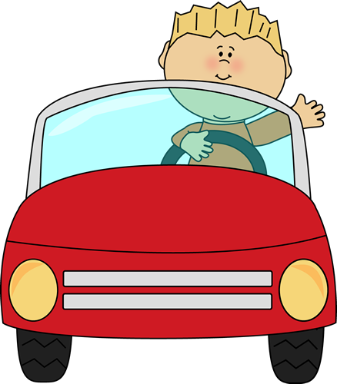 http://www.mycutegraphics.com/graphics/car/boy-driving-car.html

“If all my possessions were taken from me with one exception, I would choose to keep the power of communication; for by it, I would soon regain all the rest.”
-Daniel Webster

